**Hadiah 1a berkurang**

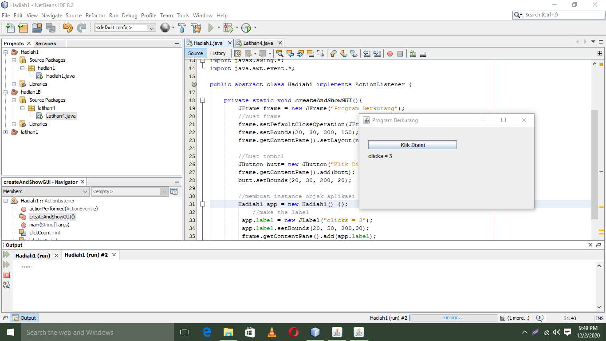

package hadiah1;

/**

*

* @author admin

*/

import javax.swing.*;

import java.awt.event.*;

public abstract class Hadiah1 implements ActionListener {

private static void createAndShowGUI(){

JFrame frame = new JFrame("Berkurang");

//buat frame

frame.setDefaultCloseOperation(JFrame.EXIT_ON_CLOSE);

frame.setBounds(20, 30, 300, 150);

frame.getContentPane().setLayout(null);

//Buat tombol

JButton butt= new JButton("Klik Disini");

frame.getContentPane().add(butt);

butt.setBounds(20, 30, 200, 20);

//membuat instance objek aplikasi

Hadiah1 app = new Hadiah1() {};

//make the label

app.label = new JLabel("clicks = 3");

app.label.setBounds(20, 50, 200,30);

frame.getContentPane().add(app.label);

butt.addActionListener(app);

frame.setVisible(true);

}

public void actionPerformed(ActionEvent e) {

clickCount-=1;

label.setText("clicks = "+clickCount);

}

public static void main(String[] args) {

// TODO code application logic here

SwingUtilities.invokeLater(new Runnable (){

public void run(){

createAndShowGUI();

}

});

}

int clickCount= 3;

JLabel label;

}

**Hadiah 1B bertambah**

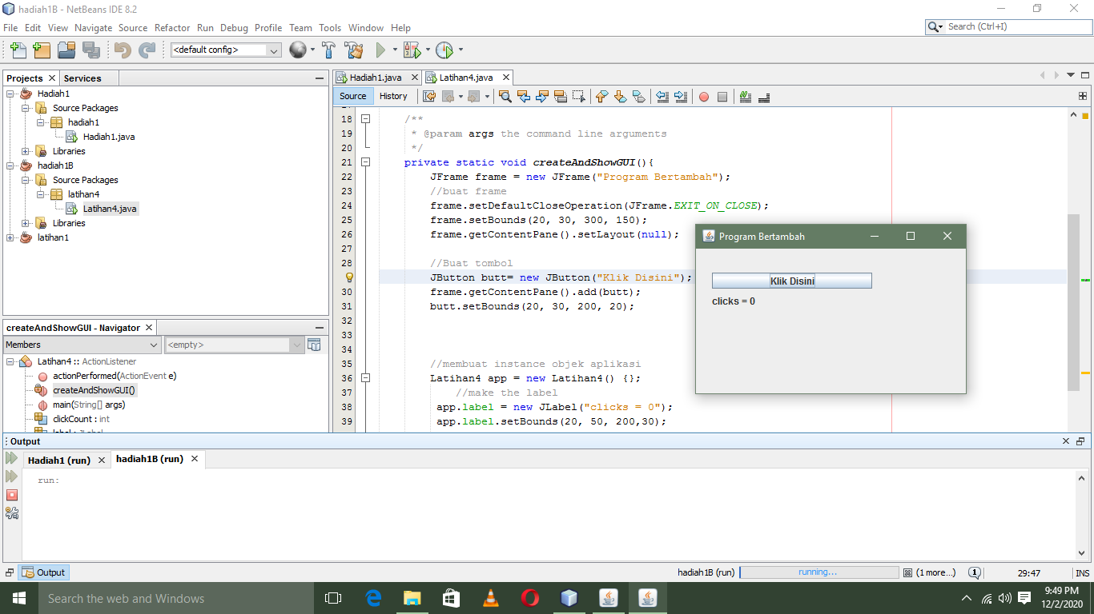

**package latihan4;**

/**

*

* @author admin

*/

import javax.swing.*;

import java.awt.event.*;

public abstract class Latihan4 implements ActionListener{

/**

* @param args the command line arguments

*/

private static void createAndShowGUI(){

JFrame frame = new JFrame("Bertambah");

//buat frame

frame.setDefaultCloseOperation(JFrame.EXIT_ON_CLOSE);

frame.setBounds(20, 30, 300, 150);

frame.getContentPane().setLayout(null);

//Buat tombol

JButton butt= new JButton("Klik Disini");

frame.getContentPane().add(butt);

butt.setBounds(20, 30, 200, 20);

//membuat instance objek aplikasi

Latihan4 app = new Latihan4() {};

//make the label

app.label = new JLabel("clicks = 0");

app.label.setBounds(20, 50, 200,30);

frame.getContentPane().add(app.label);

butt.addActionListener(app);

frame.setVisible(true);

}

public void actionPerformed(ActionEvent e) {

clickCount++;

label.setText("clicks = "+clickCount);

}

public static void main(String[] args) {

// TODO code application logic here

SwingUtilities.invokeLater(new Runnable (){

public void run(){

createAndShowGUI();

}

});

}

int clickCount=0;

JLabel label;

}